Performance Improvement Plan
Student’s Name
Instructor’s Name
Date

Performance Improvement Plan
A hospital has encountered health quality and patient safety challenges in the surgical department. Several challenges encountered include patient registration errors, billing errors and interruptions and suspensions in payment of insurance companies. The surgical department performs around twenty minor surgeries to outpatient customers including endoscopy, urology procedures, cataract removal and gastrointestinal procedures. Although the hospital has a procedure to follow in the registration and scheduling of the surgical process, there are still issues encountered in the hospital which leads to hiring a new outpatient manager. The new manager realized that the front office is not organized to cater for tasks available. On the other hand, the clerks responsible for registration do not have good working coordination. This comes when the new manager came and asked them the reason behind registration errors and they answered the problem is as a result of lack of appropriate information regarding insurance cover from the surgical officers. Again, when asked about the billing errors, the clerks answered that patients always forget to carry copies of their insurance cover and they end up registered as self-pay. Furthermore, calls are not tracked when a patient calls the next day to provide the card information and other factors such as the insurance courier not authorizing the surgery earlier.
The registration office is also in a mess as clerks always inform patients to come early for the registration process and they are not well prepared. For instance, the fax machines run out of paper and thus some information recorded is incomplete and there is less privacy during the gathering of patient’s personal information. Moreover, names used in bracelets are misspelled the hospital does not focus on achieving their goals. For example, they have set an eighty percent customer satisfaction and only attain a sixty percent while they purchased a new computer system that will cater to problems associated with call tracks and authorization but it is not used. For that reason, the surgery center might lose in their business due to these problems since surgeons say that they won’t come back to the surgery center if the problems still exist.
Monitoring in a hospital is an inclusive way of ensuring the provision of quality healthcare to patients. Quality healthcare involves a lot of providing the care the patients required when they need it in a safe, affordable and efficient way. However, the quality of healthcare may also involve engaging the patient in preventing care and in the treatment of a diagnosed condition (Fatima et al., 2018). The new manager should set a monitoring plan to allow them to improve the provision of feedback to healthcare staff such as the surgeons, nurses and clerks. Besides, this will help to offer training to clerks and allow them to understand the need for change to accommodate improvement in customer satisfaction and designing solutions to cater to quality gaps in the surgery center.
The new manager needs to first assess the current process used in the surgical center to enable him to identify and eliminate mistakes in the registration. The hospital system does have a different interdependent part that provides an outcome. The different departments or parts in the hospital perform different procedures to the patient and nothing functions in isolation. Hence, the new manager should first understand the procedures and processes followed in the surgery center when providing services. For example, in a surgical center, the procedure to be followed would first the patient to pre-schedule for surgery a few days before the actual surgery is conducted. The process is facilitated by both the surgeon’s office and the outpatient registration staff. Consequently, the outpatient center gathers the information from the surgeon's medical offices through the fax and is provided by the surgery coordinator. A nurse who is the surgery coordinator will then call the patient to perform a pre-evaluation, make needed tests and gives the patient overall instructions regarding the preparation of the surgery and provides them the time they will be needed for surgery. Again, when patients come to the surgery center the day they were provided by the surgery coordinator, the patient will first be registered with clerks at the front office and be given a bracelet with their name. The patient is then taken to the surgery room and is discharged the following day through following the stipulated procedures and offered some information to follow up and finally the satisfaction survey conducted by the hospital after a week.
The new manager needs to collect data frequently regarding the registration process, the data will then be assessed to identify the causes of the prevailing negative outcomes leading to poor performance. The manager will then perform a standard quality measurement for those working in the registration area. They should have the professional expertise to work in that field, the standards should be realistic, clear and reliable. Also, the manager will need to know why the front office clerks are resistant to change, be able to provide the best solutions without offending any staff and why the computer system purchased to permit tracking of calls but it is not used.
Consequently, the communication skills of front office clerks and surgery coordinators should be measured to identify the effects associated with their communication skills. The measure will be enabling the manager to know the proficiency of their workers and also allow them to know how clerks and nurses would be communicating to patients (Arnold & Boggs, 2019).

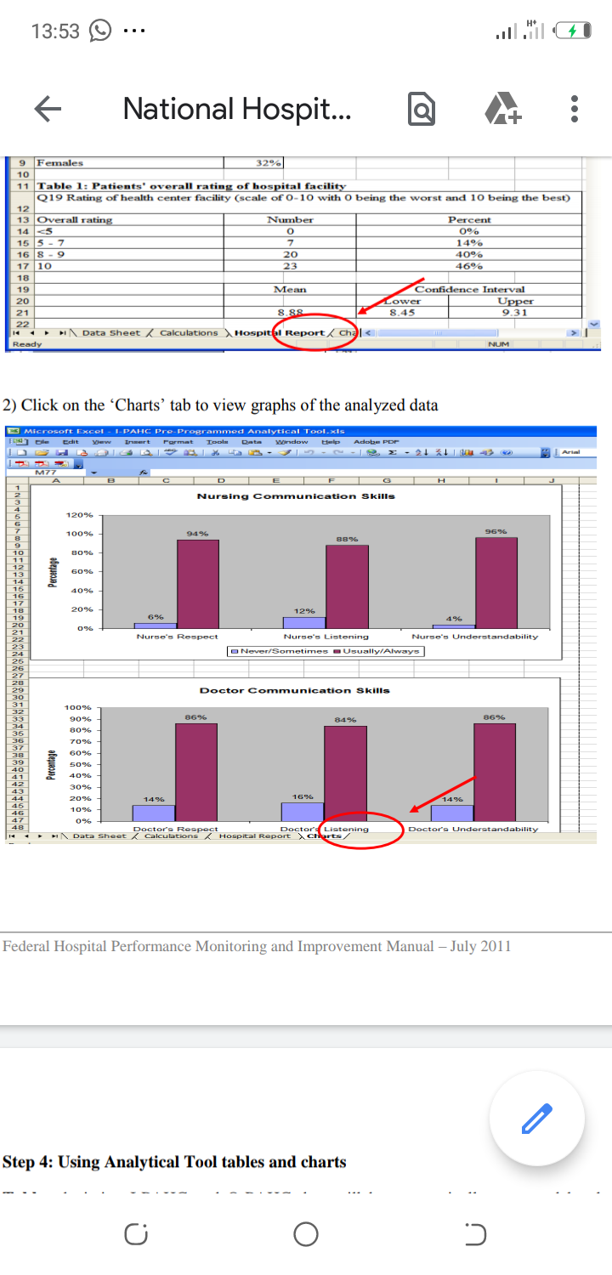

Figure 1: Good communication skills by nurses.
The new manager should also use key performance measures to know if the hospital is moving towards achieving its objectives and goals. Through the manager focusing on key performance measures, they will familiarize and understand how the hospital is performing. The best key performance indicator is the one that acts as a compass to the manager by helping them and their team to know if they are heading in the right direction of their goals (Si et al., 2017). In addition, an efficient key performance indicator is the one that is well defined and measurable. For example, the surgical center has set its goals to be at eighty percent customer satisfaction but they only achieve sixty percent. The measure of customer satisfaction can be measured but the hospital is doing nothing to increase customer satisfaction. Nonetheless, the front office clerks keep on is blaming other staff for registration errors. Therefore, the key performance indicators should be moving towards the target for the manager to know the performance of the hospital when moving in the right direction.

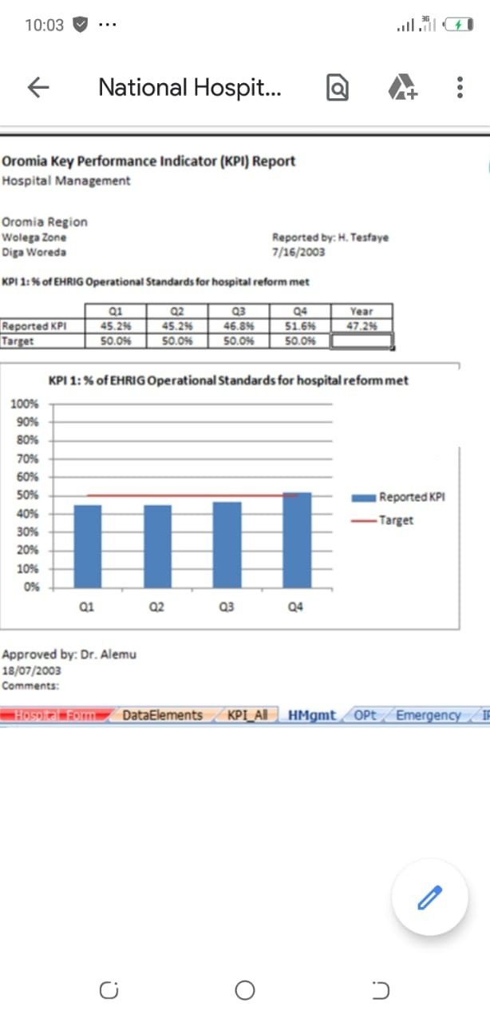
Figure 2: Shows if the hospital is performing towards goals or targets.
The new manager will need to have a meeting with all the staff and inform them about the issues that are affecting them. All staff should be involved in finding ways and implementing the methods for finding the best quality improvement plan. When staffs meet the key management leaders, they will easily be motivated. Also, the manager will be able to inform the staff about the benefits that are available when they implement the best system and ensure quality service is offered to patients. Staff will comply when they are involved in every quality improvement meetings and training that will be required. However, the process should be done by the new leader or the quality monitoring leader selected every day and reports presented after a specific day to know the progress.
Structural measures evaluate ability of healthcare providers in provision of evidence-based care to patients. The new manager should ensure that they have facilitated the hospital with good electronic medical records and systems that will enable the hospital to achieve the best patient information with minimal errors as possible and also ensure efficient collections of patients’ data. On the other hand, process measures to fuel the hospital to keep measures that will improve the health of either healthy or those diagnosed with health issues (Gu & Itoh, 2016). Thus, the surgical center should create an education program for all people to educate them about certain conditions that may arise and require surgery to be able to identify conditions easy and earlier before they become severe. Also, the outcome measure is good to identify the effectiveness of treatment. The current status of a patient is known through the measure and the surgical center may decide to ask patients to come for clinics to be examined and know the progress. Last but not least, the customer satisfaction measure is conducted to retain customers. The manager may conduct surveys to customers or evaluate the competitions and determine why people prefer other competitors than their hospital.

References
Arnold, E. C., & Boggs, K. U. (2019). Interpersonal Relationships E-Book: Professional Communication Skills for Nurses. Elsevier Health Sciences.
Fatima, T., Malik, S. A., & Shabbir, A. (2018). Hospital healthcare service quality, patient satisfaction and loyalty. International Journal of Quality & Reliability Management.
Gu, X., & Itoh, K. (2016). Performance indicators: healthcare professionals’ views. International journal of health care quality assurance.
Si, S. L., You, X. Y., Liu, H. C., & Huang, J. (2017). Identifying key performance indicators for holistic hospital management with a modified DEMATEL approach. International journal of environmental research and public health, 14(8), 934.

